**MANUAL FOR INTEL REAL SENSE D345i CAMERA**

**Product Collection** - Intel® RealSense™ Cameras

**Camera Model Name** – D345i

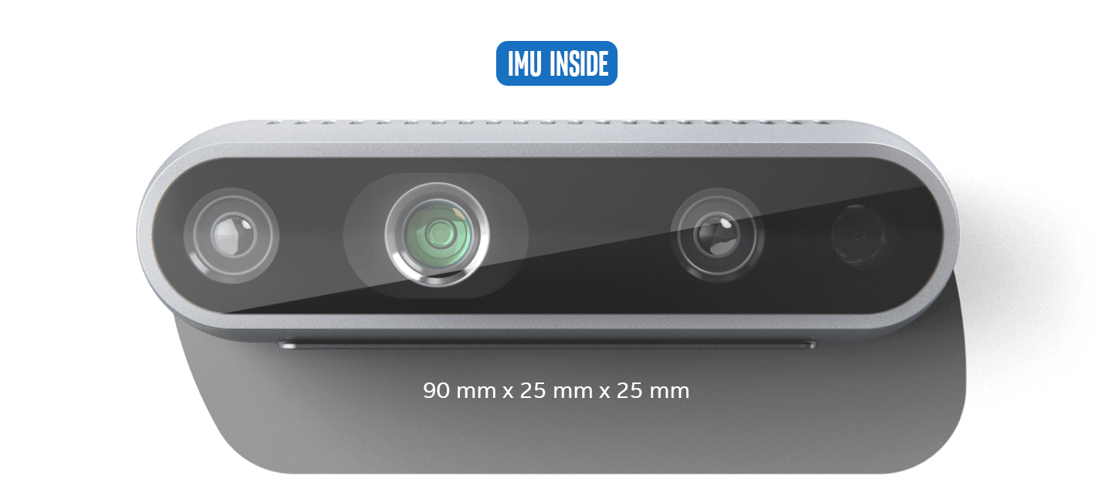

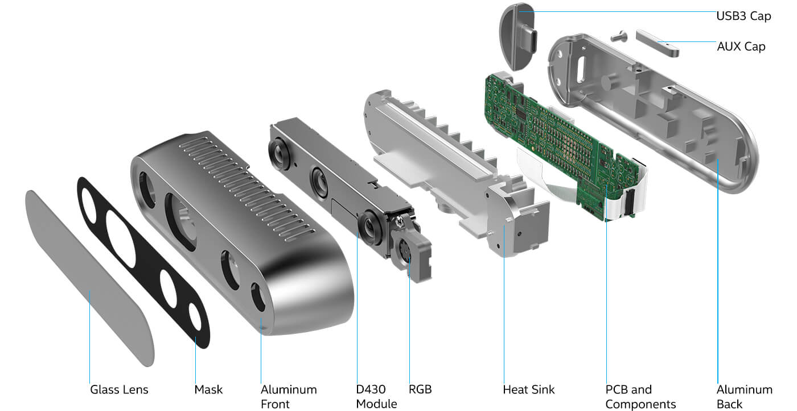

**More details of D345i:** <https://www.intelrealsense.com/depth-camera-d435i/>

**Datasheet:** [https://www.intelrealsense.com/developers/#whitepaper](https://www.intelrealsense.com/developers/%23whitepaper)

**Software download:** <https://github.com/IntelRealSense/librealsense/releases/download/v2.55.1/Intel.RealSense.SDK-WIN10-2.55.1.6486.exe>

**Applications:**

Intel RealSense cameras offer a wide range of applications across various domains, here are some common use cases:

1. **Robotics**
2. **Retail**
3. **3D Scanning**
4. **Skeletal and People Tracking**
5. **Drones**
6. **Object Measurement**